New-type Urbanization Policy, Urban Expansion, and Employment Quality in Chinese Cities: Evidence from a Quasi-natural Experiment in China

Bingchen Liᵃᵇ, Wenbo Lvᵃ, Hu Dingᶜ, Yongze Songᵈ Wufan Zhaoᵃ*,
ᵃ Urban Governance and Design Thrust, Society Hub, The Hong Kong University of Science and Technology (Guangzhou) 511453, China.
ᵇ Spatial Sciences Institute, University of Southern California, Los Angeles 90018, USA.
ᶜ School of Geography, South China Normal University, Guangzhou 510631, China.
ᵈ School of Design and the Built Environment, Curtin University, Perth 6102, Australia.

* Corresponding author: wufanzhao@hkust-gz.edu.cn (Wufan Zhao).

Abstract: Rapid urbanization has reshaped China’s labor markets, raising the question of whether policy-driven urban development can deliver not just more jobs, but better jobs. Our analysis shows that the New-type Urbanization Pilot Policy (NTUPP) has significantly enhanced employment quality in Chinese cities. We employ panel data from 287 prefecture-level cities in China from 2007 to 2021, using the implementation of New Type Urbanization Pilot Policy as a quasi-experiment to empirically examine the policy impact on employment quality in China. The result reveal that, compared with the control group, the employment quality in pilot cities increased by an average of about 12.13%. Further analysis indicates that the policy’s effects are realized primarily through human capital accumulation and factor market development, with stronger improvements observed in cities characterized by compact spatial forms and vertical expansion, while excessive horizontal sprawl weakens the benefits. We further find that the policy’s effects are heterogeneous across cities, being more pronounced in eastern, southern, coastal, and transportation hub cities. Moreover, the policy generates positive spillover effects on neighboring cities. These findings underscore the effectiveness of the NTUPP in improving employment quality and the critical role of urban spatial design in sustaining such effect.

Keywords: New-type Urbanization Pilot Policy; Employment Quality; Human Capital; Urban Spatial Form

1 Introduction
Employment is a cornerstone of economic and social development. Beyond providing income and livelihood security, high-quality employment contributes to human capital accumulation (Van 2021), supports social mobility, and ensures that economic growth translates into broad-based welfare improvements (Peckham et.al, 2022). In developing and transitional economies, enhancing the quality of employment is particularly crucial, as it determines whether structural transformation generates inclusive and sustainable outcomes (Duernecker et al., 2022). While Urbanization fundamentally reshapes labor markets. By concentrating population and economic activity, urbanization fosters agglomeration economies, improves matching efficiency, and accelerates the transition from agriculture to industry and services (Wang & Zhang, 2023; Xu & Jiao, 2021).
Yet, the benefits of urbanization crucially depend on the spatial form of urban expansion. Horizontal sprawl, characterized by low-density built-up areas, often leads to inefficient land use, longer commuting distances, and fragmented public service provision (Yang & Zhao 2022; An et al. 2025), thereby weakening the potential gains from agglomeration. In contrast, compact urban forms can reduce transaction costs, facilitate knowledge spillovers, and enhance land use efficiency (Yu et al 2024; Sun & Xu 2025; Cheng & Wang, 2021), thus generating more favorable labor market outcomes. At the same time, vertical expansion—reflected in taller buildings and higher-density development—can further intensify agglomeration economies by accommodating population growth within limited land, improving accessibility, and supporting the clustering of productive activities (Duranton & Genovese, 2020). These spatial dynamics highlight that urbanization is not only a process of quantitative population concentration but also one of qualitative spatial reconfiguration (Genovese et al. 2023), in which the morphology of cities shapes how agglomeration translates into employment opportunities and job quality. For China—the world’s largest and fastest case of urbanization—the critical policy question is therefore not merely whether urbanization creates jobs, but whether different forms of urban growth and spatial expansion lead to improvements in the quality of employment. Since the release of the National New-type Urbanization Plan (2014–2020), China has shifted from land and investment-led expansion toward a more human-centered urbanization strategy, emphasizing migrant integration, equal access to public services, and social welfare enhancement (Li & Song, 2020). While recent research has examined how urbanization influences infrastructure, industrial upgrading, and regional growth (Li et al., 2024; Gong & Xu 2024; Deng et al.,2023), systematic evidence on its effects on employment quality remains scarce. Existing studies tend to focus either on employment quantity or rely on provincial-level aggregates, leaving limited understanding of how institutional reforms affect labor markets at the city level, where heterogeneity is most pronounced.
This study examines whether the New-type Urbanization Pilot Policy (NUPP) has enhanced employment quality in Chinese cities, focusing on the mechanisms of human capital accumulation and industrial upgrading, as well as the moderating role of urban spatial form and compactness. This paper makes for potential contributions. First, we construct a novel city-level multidimensional index of employment quality and exploiting the staggered rollout of the NTUPP as quasi-natural experiment, provide the causal evidence that the policy significantly improves employment quality in pilot cities. Second, we integrate a new remote-sensing dataset on building heights (CBHD30) to derive measures of building surface fraction (BSF) and mean building height (MBH), which capture both horizontal and vertical dimensions of urban expansion, and incorporate these measures into the empirical analysis to investigate how urban morphology moderates the policy’s impact on employment quality. Third, we examine the heterogeneity of the policy’s effects across different types of cities and further identify spatial spillover effects on neighboring areas.
This Papper provide three contributions to existed literature. i) Empirically, we identify the promotional effect of the NUPP on employment quality at the city level. ii) Substantively, we introduce novel 3D measures of the built environment into the analysis, allowing us to assess how horizontal and vertical urban forms condition the policy impact.. iii) Extending beyond direct effects, we document spatial spillovers of the NTUPP , which highlighting its broader regional implications.
- Background and theoretical mechanisms
2.1 Urbanization and employment
In 2014, the Chinese government launched the New-type Urbanization Policy (NTUPP) with the aim of promoting sustainable urban growth, improving employment quality, and fostering inclusive development. Compared with traditional urbanization strategies, the NTUPP emphasizes not only spatial expansion but also the improvement of human capital, industrial upgrading, and market development. The policy provides institutional support for enhancing employment quality through coordinated land use, infrastructure investment, and labor market reforms.
A growing body of research has examined the multifaceted relationship between urbanization and employment outcomes. Cross-country studies highlight that urbanization can reduce vulnerable employment and enhance labor market performance when supported by structural transformation (Chen et al., 2023), while regional evidence suggests heterogeneous effects depending on trade, foreign investment, and gender dynamics (Nica et al., 2023). Within China, urbanization quality is closely tied to city size and industrial structure (Xu & Jiao, 2021), and factors such as industrial agglomeration (Wu et al., 2022) and macroeconomic growth (Guo et al., 2022) have been identified as key drivers of urban expansion and labor market upgrading. At the same time, scholars emphasize the potential downsides of rapid urbanization, including poverty suburbanization and limited job accessibility (Delmelle et al., 2021), environmental pressures (Abbasi et al., 2021), and spatial disparities in urban growth across different national contexts (Pilehvar, 2021; Park, 2023). Overall, while prior studies underline the role of urbanization in shaping employment outcomes, most have paid less attention to the quality dimension of employment and its institutional underpinnings.
Recent work has shifted attention toward how urban spatial form and morphology mediate these effects. Compact and transit-oriented urban structures are found to improve job accessibility and mitigate spatial mismatch (Lyons & Ewing, 2021; Bastiaanssen et al., 2022), while fragmented or sprawling urban development often exacerbates inequality and weakens labor market efficiency (Alshammari et al., 2022; Mun et al., 2024). Empirical evidence from China shows that spatial structure can accelerate employment growth by facilitating agglomeration and industrial linkages (Xiao et al., 2022), whereas international studies reveal that urban sorting and income stratification interact strongly with spatial form (Couture et al., 2024). More recently, scholars have highlighted the need to account for both horizontal and vertical expansion, as volumetric sprawl produces distinct implications for sustainability and labor market outcomes (Soltani et al., 2025). These insights underscore that the economic and employment effects of urbanization cannot be disentangled from its spatial configurations, yet systematic analyses that link policy-induced urbanization, employment quality, and urban form remain scarce.
Existing studies show that urbanization influences employment outcomes and that spatial form matters, but they largely overlook the quality dimension of employment and how policy-driven urbanization interacts with urban morphology. This paper addresses these gaps by examining the effects of the New-type Urbanization Pilot Policy (NTUPP) on employment quality in Chinese cities and the moderating role of spatial form.
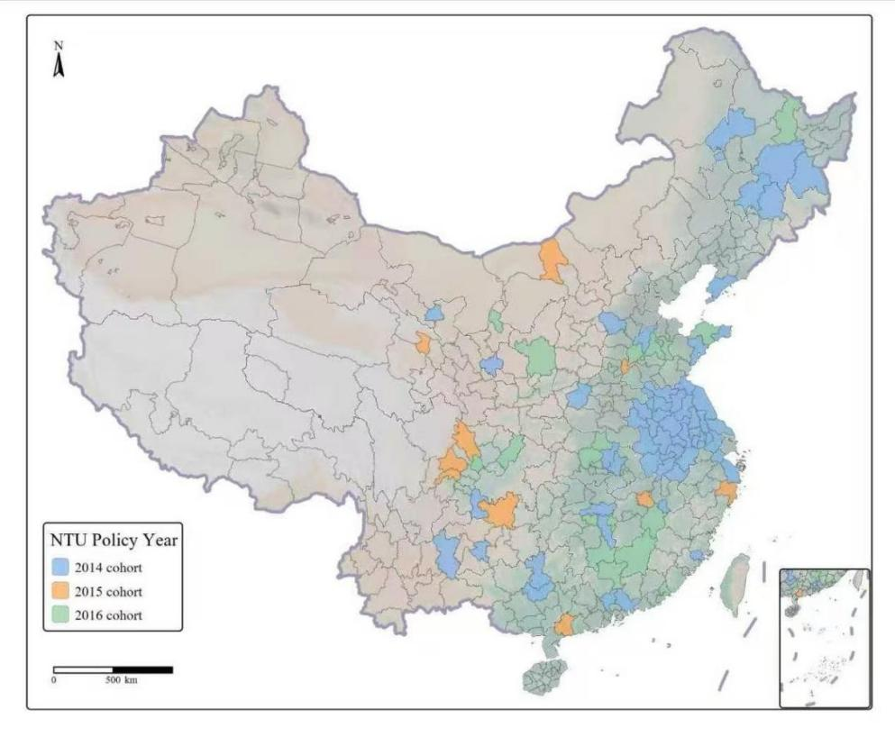
Panel A NTU policy cohort distribution.
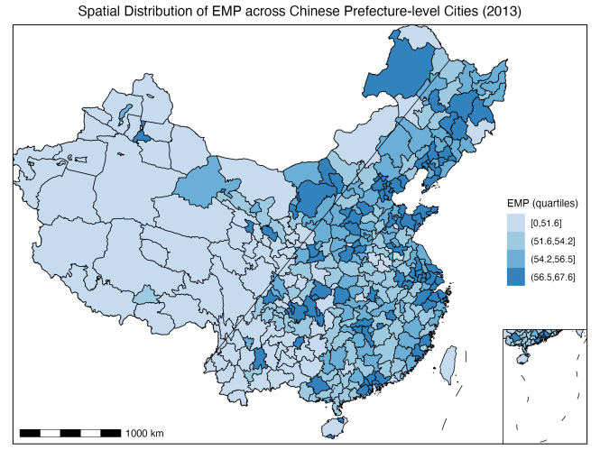 | 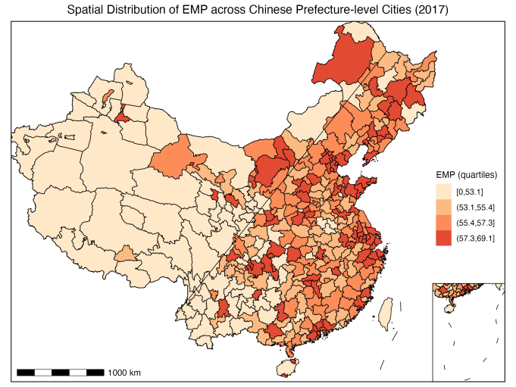
Panel B EMP distribution in 2013. | Panel C EMP distribution in 2017.
Fig.1. Spatial Distribution of NTU Policy Cohorts and EMP.Panel A shows the timing of NTUPP approvals.

2.2. Theoretical mechanisms
The NTUPP directly influences urban employment quality by reshaping the institutional and spatial foundations of urban development. First, the policy emphasizes coordinated urban planning and infrastructure investment, which reduces mismatches between labor supply and demand and provides more equitable access to job opportunities (Liao&Tian, 2024). Second, by improving the provision of public services such as education, healthcare, and transportation, the NTUPP lowers barriers to labor mobility and enables workers to participate in higher-quality employment(Wang et al., 2025). Third, the NTUPP strengthens institutional support for industrial upgrading and entrepreneurship, thereby stimulating demand for skilled labor and creating more stable and diversified job opportunities (Wang & Qiu, 2023). Through these mechanisms, the NTUPP is expected to enhance both the quantity and quality of employment in urban areas.
Urban spatial expansion may influence the extent to which the NTUPP improves employment quality. When urban growth primarily takes the form of 2D expansion (horizontal sprawl), it often generates dispersed settlement patterns, inefficient land use, and fragmented infrastructure provision (Xiao et al., 2022). Horizontal sprawl also increases commuting distance and costs, which can exacerbate the spatial mismatch between jobs and workers. These inefficiencies weaken the effectiveness of urban policies that aim to enhance employment quality, as the benefits of institutional support and public service provision are partly offset by rising urban costs and declining spatial accessibility(Zhao et al., 2020). Thus, extensive 2D expansion is expected to attenuate the positive impacts of the NTUPP on employment outcomes.
By contrast, 3D expansion (vertical densification) offers a more efficient growth path. Concentrating population and activity within existing urban footprints optimizes land use and lowers per-capita infrastructure costs (He et al., 2020). Denser built environments raise job accessibility, shorten commutes, and improve matching efficiency, supporting more productive labor allocation (Delmelle et al., 2021). Crucially, densification strengthens agglomeration economies—the sharing, matching, and learning mechanisms through which proximity boosts productivity—thereby magnifying the policy channels (infrastructure upgrading, human-capital accumulation, firm upgrading) through which the NTUPP improves employment quality. This logic aligns with classic evidence that urban concentration fosters knowledge spillovers and growth (Glaeser et al., 1992) and that cities generate a learning premium that raises workers’ skills and wages (Glaeser & Maré, 2001). Thus, vertical densification should reinforce the NTUPP’s effects on high-quality employment (Zhao et al., 2025).
Beyond its direct influence, the NTUPP is expected to improve urban employment quality through indirect mechanisms. One important channel is human capital enhancement. By expanding access to education, vocational training, and healthcare, the NTUPP helps raise the skill levels and overall productivity of the urban labor force(Wang & Qiu, 2023). Skilled workers are more adaptable to structural changes in the labor market and more likely to access stable, formal, and higher-paying jobs. In addition, higher human capital facilitates innovation and entrepreneurship, which further generate diverse employment opportunities(Hosseinioun et al., 2025). Consequently, the NTUPP’s emphasis on strengthening human capital indirectly translates into improvements in urban employment quality.
Another key channel is market development. The NTUPP encourages the growth of urban markets by improving infrastructure, fostering industrial upgrading, and promoting institutional reforms that lower transaction costs(Wang et.al., 2024). Well-developed markets expand business opportunities for firms, attract investment, and stimulate demand for labor, particularly in the service and high-tech sectors(Zhou et al., 2024). Stronger markets also support the creation of more formal employment contracts and better working conditions. Through these mechanisms, market development serves as a conduit through which the NTUPP enhances the quality of employment in urban areas. Building on the preceding theoretical framework (illustrated in Fig. 2), we propose three core hypotheses.
Hypothesis 1: The NTUPP increases urban employment quality.
Hypothesis 2: The NTUPP enhances human capital, which in turn increases urban employment quality.
Hypothesis 3: The NTUPP promotes market development, which in turn increases urban employment quality.
Hypothesis 4a: Urban 2D expansion attenuates the policy impacts of the NTUPP.
Hypothesis 4b: Urban 3D expansion enhances the policy impacts of the NTUPP
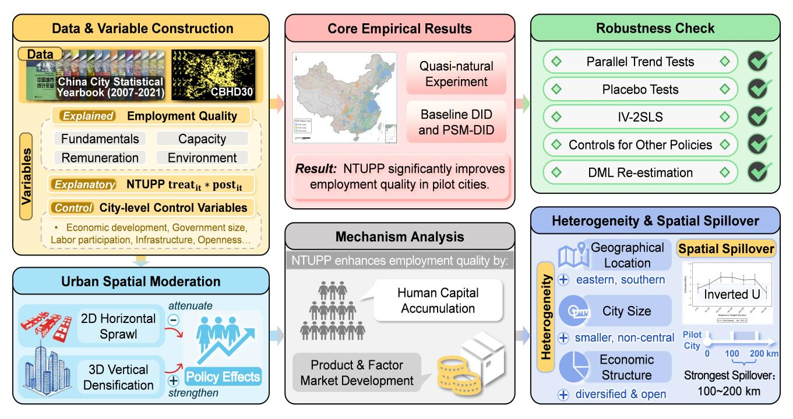
Fig.2. Mechanism of green finance pilot policy's impact on corporate employment.
3. Estimation framework
3.1. Econometric specification
To examine the impact of the New-Type Urbanization Pilot Policy (NTUPP) on urban employment quality, this study employs a multi-period difference-in-differences (DID) model with two-way fixed effects. The baseline specification is given as follows:
${EMP}_{it}=β_{0}$+$β_{1}{treat}_{it}∗{post}_{it}$+$\sum_{j=1}^{J}{φ_{it}{Controls}_{it}^{j}}+μ_{t}+α_{i}+ε_{it}$ (1)
$M_{it}=γ_{0}$+$γ_{1}{treat}_{it}∗{post}_{it}$+$\sum_{j=1}^{J}{φ_{it}{Controls}_{it}^{j}}+μ_{t}+α_{i}+ε_{it}$ (2)
Where EMP_{it} denotes the employment quality index of city_{i} in year_{t}, treat_{it}*post_{it}​ is the treatment indicator for the NTUP, Controlsit represents a vector of control variables, and μ_{t} and α_{i​}are time and city fixed effects, respectively. To further explore the underlying mechanisms through which the policy influences employment quality, we introduce a mediator variable M_{it} and construct the following two-step mediation model.Given the severe endogeneity issues associated with the traditional three-step mediation approach (Baron & Kenny, 1986), we follow the method proposed by Jiang Ting et al. (2017), adopting a two-way fixed effects framework to identify the mediation effects. Robustness tests are further conducted to examine the statistical significance of the indirect effect.
3.2. Variables selection
3.2.1. Explained variables
Urban Employment Quality serves as the core dependent variable in this study. Existing measurements of employment quality in China are mostly concentrated at the provincial level, due to limitations in data availability and inconsistent statistical standards. As a result, city-level assessments of employment quality remain relatively rare in domestic research. To better capture the structural differences and spatial distribution of employment conditions at the urban level, this study constructs and calculates a set of employment quality indicators at the prefecture-level city scale, drawing on methodologies used for provincial-level assessments. Specifically, we refer to the indicator selection logic and weighting scheme proposed by Qi et al. (2020) in their article “Digital Economy Development, Employment Structure Optimization, and Employment Quality Improvement.” That study characterizes the multidimensional nature of employment quality along three core dimensions: employment capacity, employment remuneration, and employment environment. Based on this theoretical framework and empirical approach, we adapt and extend the indicator system to match the characteristics and data availability at the city level. This refined index system provides a solid foundation for our subsequent empirical analysis.
Urban Employment Quality serves as the key dependent variable. Although most measurements in China remain at the provincial level, city-level assessment is crucial for capturing spatial heterogeneity in labor-market performance. Employment quality is conceptualized as a multidimensional construct encompassing employment capacity, remuneration, and environment, reflecting both quantitative and qualitative aspects of job conditions(Liu et al. 2023). To enhance construct validity, this framework aligns with recent international definitions of “decent work” emphasizing income, stability, and inclusiveness (ILO, 2012 ; Joshanloo., 2023). All indicators are standardized and weighted using the entropy method, which minimizes subjectivity and maintains comparability across cities. By adapting the provincial framework to the prefecture-city scale, this study provides a theoretically consistent and empirically robust measure of employment quality suited to evaluating the effects of the NTUPP.
Table 1 Indicator System
Dimension | Indicator | Direction
Employment Fundamentals | Regional economic development level | Positive (+)
 | Regional employment level | Positive (+)
 | Regional unemployment level | Negative (−)
 | Share of employment in the tertiary sector | Positive (+)
 | Urban–rural income gap | Negative (−)
Employment Capacity | Number of general higher education institutions | Positive (+)
 | Average years of schooling | Positive (+)
 | Local government education expenditure | Positive (+)
Employment Remuneration | Number of participants in basic medical insurance | Positive (+)
 | Number of participants in basic pension insurance | Positive (+)
 | Number of participants in unemployment insurance | Positive (+)
Employment  Environment | Average wage in urban private units | Positive (+)
 | Number of social security and welfare institutions | Positive (+)
 | Number of books in public libraries | Positive (+)
 | Number of hospital beds | Positive (+)

3.2.2. Explanatory variables
The core explanatory variable in this study is the interaction term treatit*postit, representing the implementation effect of China’s National New-type Urbanization Pilot Policy. Specifically, treatit is a dummy variable equal to 1 if cityi is designated as a pilot city, and 0 otherwise; postit is a time dummy equal to 1 for years after the policy implementation, and 0 before. The interaction term captures the DID effect, measuring the average treatment effect of the urbanization policy on treated cities over time.
3.2.3. Control variables
To account for confounding factors affecting urban employment quality, this study includes several city-level control variables widely adopted in urban and regional economics. Economic development (econ) reflects income and productivity differences that shape labor demand (Aghion et.al, 2021). Government size (gov) captures fiscal capacity and public service provision influencing employment quality (Banerjee et al., 2020). While conceptually related, labor participation rate (lpr) reflects labor supply rather than employment outcomes; thus, it is included as a complementary control. Infrastructure (infra) affects accessibility and firm agglomeration (Duranton et al., 2023). Openness (open) promotes technology spillovers through FDI (Yuan et al., 2025). Urbanization rate (urban) represents agglomeration effects(Yuan et al., 2025). Education level (edu) proxy human capital and innovation dynamics (Zhang et al., 2020). These variables collectively capture major socioeconomic dimensions relevant to both the policy implementation and employment outcomes.
3.3 Data sources and descriptive statistics
Considering the parallel trend assumption required for the DID model, the study period should be sufficiently long to capture policy dynamics before and after implementation. This study selects the period from 2007 to 2021, based on the following rationale: prior to 2006, many cities exhibited inconsistencies and data gaps in statistical indicators due to non-standardized reporting practices in official yearbooks. From 2007 onward, statistical systems became more standardized and data quality improved significantly, providing a more reliable foundation for constructing a consistent and comparable panel dataset.The socioeconomic and policy variables used in this study are obtained from multiple authoritative sources, including the WIND database, the China City Statistical Yearbook, the China Urban Construction Statistical Yearbook, and provincial statistical yearbooks. To ensure data quality and the robustness of empirical results, two adjustments are made to the sample: (1) regions with substantial data gaps are excluded; (2) cities with missing or abnormal values in key variables are removed from the dataset. For variables with minor missing values, linear interpolation is applied. In the end, we construct a balanced panel dataset covering 287 prefecture-level and above cities over 15 years (2007–2021) as the basis for empirical analysis.
To further capture the spatial dimension of urban development, we integrate a novel dataset on building surface fraction (BSF) and mean building height (MBH) derived from the China Building Height Dataset at 30 m resolution (CBHD30) developed by Yang et al. (2024). The construction of large-scale building height datasets has benefited from recent advances in remote sensing and deep learning techniques. In particular, building-height retrieval from single-source aerial imagery has been substantially improved through contrastive learning and multi-scale refinement frameworks (Zhao et al., 2023), enhancing the accuracy and reliability of three-dimensional urban morphology measurements.
This dataset is developed by combining NASADEM (2000), ALOS AW3D30 (2010), and Copernicus DEM (2015) with the Global Artificial Impervious Area (GAIA) data to estimate building heights across China, employing slope correction and multi-source validation techniques. The CBHD30 provides temporally consistent building height data for 2000, 2010, and 2020, with a nationwide RMSE of approximately 9.15 m and a MAE of 6.25 m, validated against Baidu Map building floor data and field measurements. This long-term, high-resolution dataset enables us to characterize both horizontal (BSF) and vertical (MBH) dimensions of urban expansion, which are then matched with the socioeconomic panel to explore the interaction between urban morphology, policy implementation, and employment quality.
Figure 3 illustrates differences in the core outcome variable (EMP) and major covariates between treatment and control cities prior to policy implementation. Bars denote group means and error bars represent 95% confidence intervals. The reported t-statistics are obtained from two-sample tests of mean equality. The results provide preliminary evidence of systematic differences between the two groups.
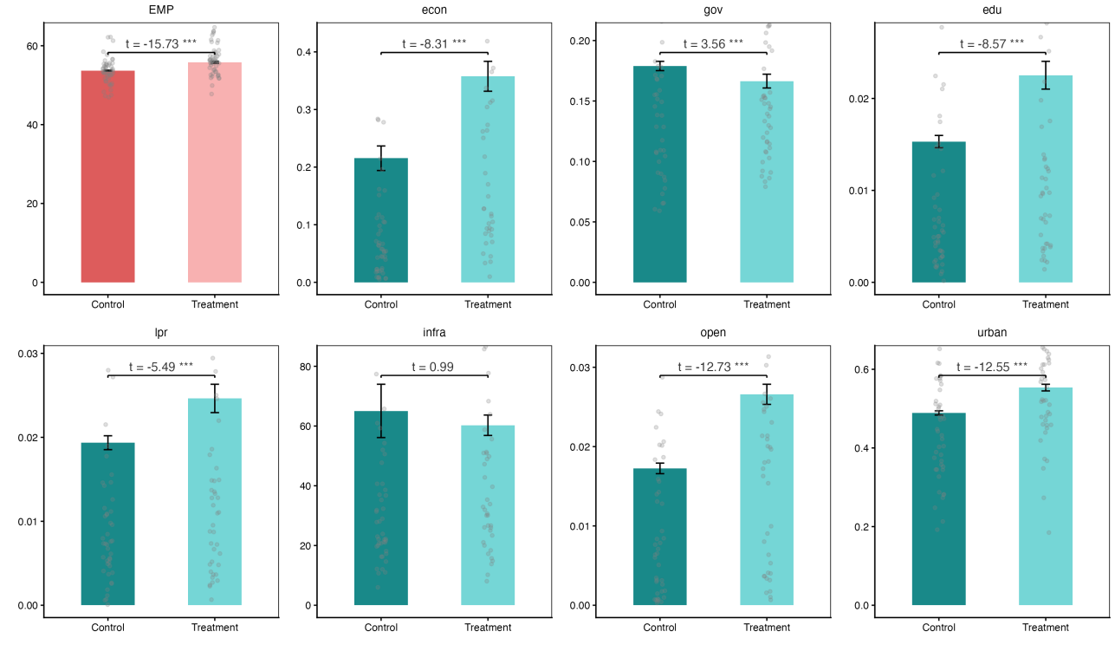
Fig.3. Descriptive Comparison Between Control and Treatment Groups

4 Empirical results
4.1 Baseline regression
Table 1 reports the baseline regression results estimating the effect of the NTUPP on employment quality. Columns (1) and (2) presented the results from a standard two-way fixed effects (TWFE) model, while Columns (3) and (4) report the results after applying propensity score matching (PSM) to address potential sample selection bias. Across all specifications, the coefficient on the interaction term treat*post is positive and statistically significant, confirming the robust and favorable effect of the pilot policy on employment quality. In the basic fixed effects models, the estimated coefficients are 0.1238 and 0.0899, respectively, with the latter controlling for a full set of covariates. The positive and significant estimates suggested that cities implementing the policy experienced a notable improvement in employment quality compared to the control group.
To further enhance the credibility of causal inference, we employed PSM to construct a matched sample of treated and untreated cities with similar pre-policy characteristics. The results in Columns (3) and (4) remained consistent with the baseline findings. The coefficient on treat*post increased to 0.1562 without covariates and remained statistically significant at 0.1213 after covariates are included. These results indicated that, even after adjusting for potential differences in observable characteristics, the new-type urbanization policy exerted a significant and positive impact on employment quality. Overall, the findings from both the baseline and matched models provided strong empirical evidence supporting the effectiveness of the pilot urbanization policy in enhancing local labor market outcomes.
Table 2 Baseline Regression Results
 | (1) | (2) | (3) | (4)
 | EMP | EMP | EMP | EMP
treat*post | 0.1238*** | 0.0899*** | 0.1562*** | 0.1213***
 | (0.0315) | (0.0295) | (0.0310) | (0.0299)
econ |  | 0.0979*** |  | 0.1055***
 |  | (0.0300) |  | (0.0312)
gov |  | -2.6206*** |  | -2.6325***
 |  | (0.6726) |  | (0.7866)
lpr |  | 4.1991*** |  | 3.9493***
 |  | (1.0495) |  | (1.0209)
infra |  | 0.0003*** |  | 0.0002***
 |  | (0.0000) |  | (0.0000)
open |  | 2.7389*** |  | 2.7181***
 |  | (0.6419) |  | (0.6679)
urban |  | 0.8906*** |  | 0.8937***
 |  | (0.1938) |  | (0.1920)
edu3 |  | 8.7865*** |  | 7.8510***
 |  | (1.4458) |  | (1.2191)
_cons | 55.2245*** | 55.0388*** | 55.5124*** | 55.1607***
 | (0.0092) | (0.1901) | (0.0086) | (0.2018)
CITY | Yes | Yes | Yes | Yes
YEAR | Yes | Yes | Yes | Yes
N | 4292 | 4152 | 3849 | 3849
Within R2 | 0.0037 | 0.1274 | 0.0083 | 0.1310
Note: Robust standard errors in parentheses. ***, **, and * indicate significance at the 1%, 5%, and 10% levels, respectively; same below.
4.2 Robustness check
4.2.1 Parallel trends test
When using the DID method for identification, it is essential to ensure that the treatment and control groups satisfy the parallel trends assumption prior to policy implementation. To verify this, we conducted a test of the dynamic effects of the exogenous policy shock. The specific estimation method was as follows:
${EMP}_{it}=β_{0}$+$\sum_{j=1}^{J}{β_{k}{Dummy}_{t+k}}++\sum_{j=1}^{J}{φ_{it}{Controls}_{it}^{j}}+μ_{t}+α_{i}+ε_{it}$(3)
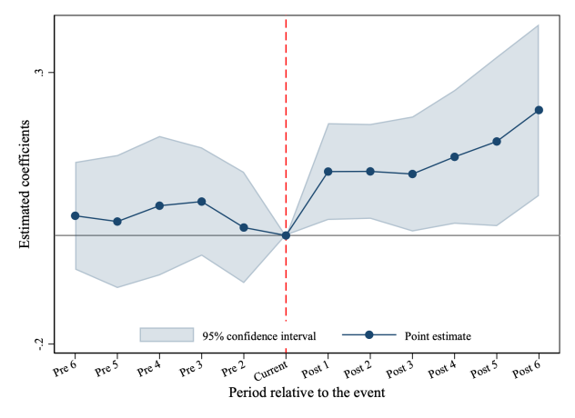
Panel A.With Control Variables
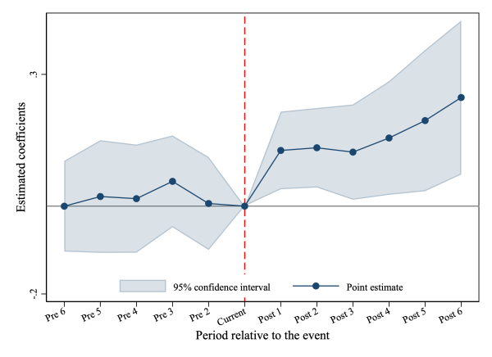 | 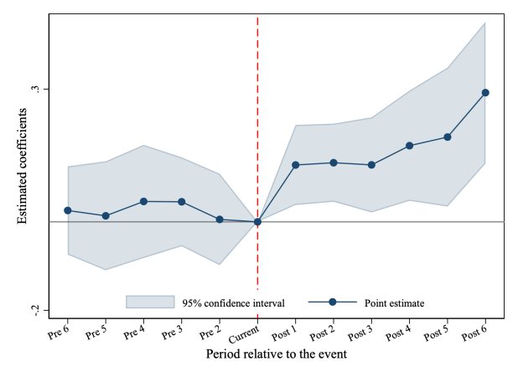
Panel B: Without Control Variables |  | Panel C: PSM-Matched Sample
Fig.3. Parallel Trends Test
In the model, Dummy_{t+k} represented a set of event-time dummy variables relative to the treatment year, with t = –1 (the year prior to policy implementation) used as the reference period. The estimated coefficients β_{k} captured the dynamic changes in urban employment quality before and after the policy intervention. Control variables included a range of city-level economic indicators, and both city and year fixed effects are included to absorb unobserved heterogeneity. Figure 1 illustrated the dynamic effects of the policy shock on employment quality. The panel A and B showed the estimates based on the full sample, while the Panel C figure presented the results after applying PSM matching. The shaded areas indicated 95% confidence intervals, and the vertical dashed line marked the timing of the policy intervention. As shown in the figure, during the pre-treatment periods (Pre–6 to Pre–1), the estimated coefficients fluctuated around zero and were statistically insignificant, lending support to the parallel trends assumption. Starting from the year of policy implementation (Current), the coefficients became increasingly positive and statistically significant, with confidence intervals excluding zero. This indicates that the pilot urbanization policy has a significant and positive dynamic effect on urban employment quality.
4.2.2 Placebo test
To further assess the robustness of the estimated policy effect and the validity of the parallel trends assumption, we conduct three placebo tests: in-time, in-space, and restricted mixed placebo tests. The in-time test shifts the treatment timing backward to examine whether artificial pre-treatment shocks generate significant effects. The in-space test randomly reassigns treatment status across units, while the restricted mixed placebo test randomizes both treatment units and timing under the staggered adoption structure.
As shown in Figure 3, the placebo estimates are centered around zero and largely insignificant across 500 repetitions. In contrast, the actual estimated treatment effect lies in the upper tail of the placebo distribution, indicating that the observed policy impact is unlikely to be driven by random assignment or spurious time trends. Overall, these results reinforce the credibility of the baseline findings.

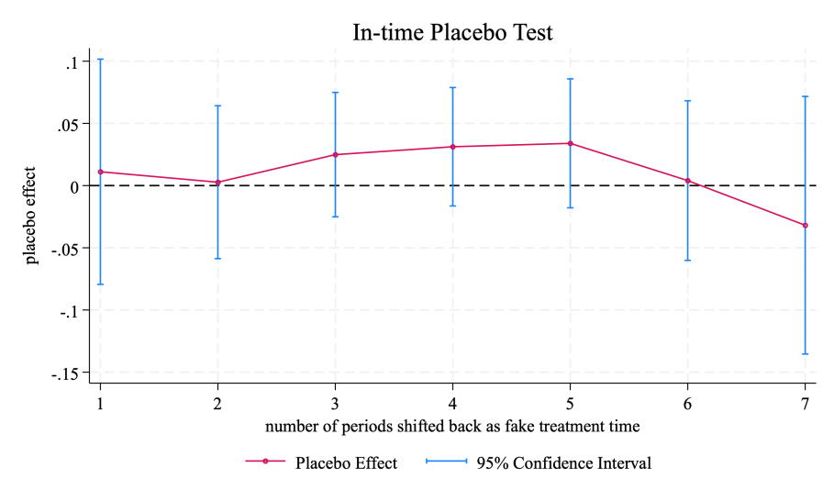
Panel A Time placebo test
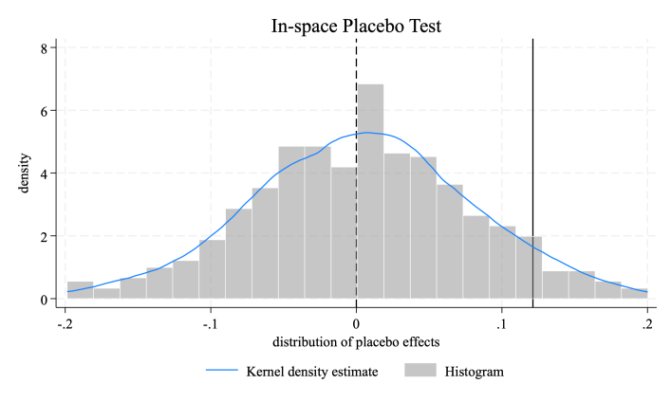 | 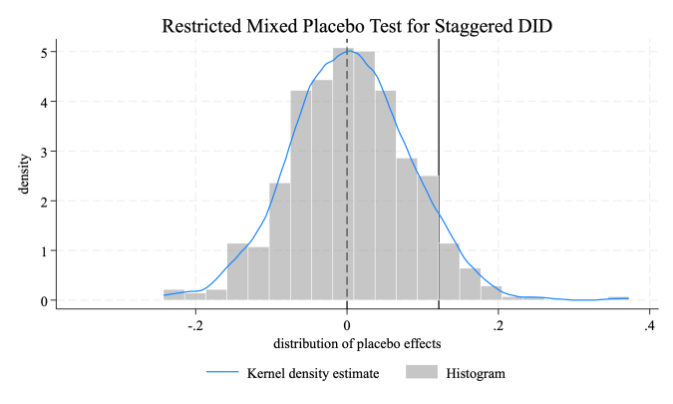
Panel B Unit placebo test | Panel C Mixed placebo test
Fig.5. Placebo Test

4.2.3 Other robustness test
To further examine the credibility of our identification strategy, we conduct three additional robustness tests.
- IV–2SLS EstimationTo address potential endogeneity concerns, we implement a two-stage least squares (2SLS) estimation using two historical-geographical instruments. The first instrument is the interaction between the number of Ming-dynasty post stations and the post indicator (IV₁ = station × post), consistent with the historical persistence argument in Banerjee et al. (2020). The second instrument is the interaction between river-network density and the post indicator (IV₂ = river density × post), motivated by geographic exogeneity as in Bleakley et al. (2012).Panel A of Table 4 reports the results. Both instruments are strongly correlated with the endogenous policy variable, with large Kleibergen–Paap LM statistics (946.68 and 1652.92). The second-stage estimates remain positive and statistically significant. The Hansen J-statistics are not rejected, supporting the validity of the exclusion restrictions. These results reinforce the causal interpretation of the policy effect.
(2) Controlling for Other Policies. We further examine whether the estimated effect is confounded by concurrent policy interventions, including the High-Speed Rail program, the Talent Attraction Policy, and the Smart City initiative. These policies may influence employment quality through infrastructure, human-capital, or agglomeration channels.Panel B of Table 4 shows that after controlling for each policy separately, the coefficient on policy × post remains positive and statistically significant. This suggests that the main results are not driven by overlapping reforms.
(3) Double Machine Learning Re-estimation Finally, we re-estimate the model using the Double Machine Learning (DML) framework proposed by Chernozhukov et al. (2018), which combines Neyman-orthogonal moment conditions with cross-fitting to mitigate bias from high-dimensional controls and nonlinear relationships. As shown in Table 6, the estimated policy effect remains positive and statistically significant across different machine-learning algorithms (Random Forest and XGBoost) and cross-fitting specifications (K = 4 and K = 5). The consistency of these estimates further strengthens the robustness of our baseline findings.
Table 3 Other robustness test
PanelA IV-2SLS
 | (1) | (2) | (3) |  | (4)
 | IV1=station |  | IV2=river density
 | treat*post | EMP | treat*post |  | EMP
IV | 0.1318*** |  | 2.7013***
 | (0.0043) |  | (0.0664)
policy*post |  | 0.3048*** |  |  | 0.1544***
 |  | (0.0513) |  |  | (0.0339)
K-P LM stat. | 946.682 |  | 1652.919
 | (0.0000) |  | (0.0000)
Hansen J stat. | 0.0000 |  | 0.0000
PanelB Confounding effects of other policies
 | EMP | EMP | EMP
policy*post | 0.0959*** | 0.0990*** | 0.0983***
 | (0.0298) | (0.0296) | (0.0295)
did_rail | -0.0182
 | (0.0231)
did_talent |  | -0.0299
 |  | (0.0287)
did_smart |  |  | -0.0402
 |  |  | (0.0277)
Panel C DML Estimation using Different Learners
 | Random Forest |  | XGBoost
 | K = 4 | K = 5 | K = 4 | K = 5
policy*post | 0.0862** | 0.0912*** | 0.0636* | 0.0804**
 | (0.0341) | (0.0334) | (0.0345) | (0.0331)
CITY | Yes | Yes | Yes | Yes
YEAR | Yes | Yes | Yes | Yes
N | 4152 | 4152 | 4152 | 4152
Standard errors in parentheses
* p < 0.10, ** p < 0.05, *** p < 0.01
4.3 Mechanism analysis
We identify two primary channels through which the NTUPP improves employment quality: human capital accumulation and market development.
4.4.1 Human Capital Effect
To examine the human capital channel, we use two measures: (1) the ratio of enrolled undergraduate and junior college students to the year-end population (labor1), and (2) total enrollment in higher education (labor2). As reported in Table 10 (Columns 1–2), the coefficient on treat×post is positive and statistically significant at the 1% level for both indicators (0.0014 and 0.0110, respectively). These results indicate that the NTUPP significantly expands higher education scale, supporting the view that improvements in human capital constitute an important mechanism behind enhanced employment quality.
4.4.2 Market Development Effect
We further investigate whether the policy operates through improvements in market development, focusing on product and factor markets. Columns (3) and (4) of Table 10 show that the policy significantly increases both the product market index (0.3334) and the factor market index (0.2339), with both coefficients significant at the 1% level. These findings suggest that the NTUPP enhances market efficiency and openness. A more developed product market strengthens competition and allocative efficiency, while improvements in factor markets facilitate labor and capital mobility. Together, these channels contribute to better job matching and higher employment quality.
Table 4 Mediation effects
 | (1) | (2) | (3) | (4)
 | Human Capital |  | Market Development
 | labor1 | labor2 | productmarket | factormarket
treat*post | 0.0014*** | 0.0110*** | 0.3334*** | 0.2339***
 | (0.0003) | (0.0021) | (0.0516) | (0.0649)
_cons | 0.0088*** | 0.0582*** | 8.6553*** | 8.0086***
 | (0.0016) | (0.0104) | (0.2948) | (0.2070)
Controls | Yes | Yes | Yes | Yes
CITY | Yes | Yes | Yes | Yes
YEAR | Yes | Yes | Yes | Yes
N | 4152 | 4152 | 4152 | 4152
r2_within | 0.1605 | 0.1426 | 0.1016 | 0.0214
Standard errors in parentheses
* p < 0.10, ** p < 0.05, *** p < 0.01
4.3 Moderating role of urban expansion
To further explore the mechanisms through which the new-type urbanization pilot policy influences employment quality, we augmented the baseline model by introducing variables that captured urban spatial expansion.
${EMP}_{it}=β_{0}$+$β_{1}{treat}_{it}∗{post}_{it}$+$β_{1}{treat}_{it}∗{post}_{it}$*${expand}_{it}$+$\sum_{j=1}^{J}{φ_{it}{Controls}_{it}^{j}}+μ_{t}+α_{i}+ε_{it}$ (4)
Urban expansion is captured by built-up area (horizontal) and average building height (vertical). We interact these measures with the policy variable to test for heterogeneous effects, while keeping all other controls and fixed effects consistent with the baseline specification.
4.3.1 Urban built-up area expansion and employment quality
Panel A illustrates how horizontal urban expansion moderates the employment effects of the NTUPP. In cities with relatively low levels of built-up area, the policy exerts a positive impact on employment quality. In contrast, in cities characterized by extensive horizontal expansion, the estimated policy effect is noticeably weaker and even turns slightly negative. The divergence between the two slopes indicates that excessive two-dimensional expansion attenuates the employment-enhancing impact of the policy. These findings suggest that uncontrolled urban sprawl may dilute policy effectiveness by reducing land-use efficiency and weakening agglomeration benefits. Overall, the evidence supports Hypothesis 4a, which posits that urban 2D expansion attenuates the policy impacts of the NTUPP.

4.3.2 Urban Compactness and Three-Dimensional Expansion
We further examine how urban spatial structure and vertical development condition the effectiveness of the NTUPP. First, measures of spatial dispersion—including average intra-urban distance and the spatial compactness index, which indicate that the policy effect is significantly weaker in more dispersed cities. The negative interaction terms suggest that greater spatial dispersion attenuates the employment-enhancing impact of the policy. Conversely, cities characterized by more compact urban forms experience stronger policy gains. These findings highlight the importance of spatial concentration in facilitating agglomeration economies, reducing commuting costs, and improving infrastructure efficiency, thereby strengthening policy transmission. Second, we assess the role of vertical expansion using city-level building height indicators for 2010 and 2020. The interaction terms between the policy variable and vertical expansion measures are positive and statistically significant in both specifications. This implies that cities with more intensive three-dimensional development benefit more from the NTUPP. Vertical density appears to enhance labor absorption capacity and productivity upgrading, amplifying the employment effects of the policy. Taken together, the evidence suggests that compact and vertically developed urban structures reinforce the positive employment impacts of the NTUPP. These results provide strong support for Hypothesis 4b, which posits that urban 3D expansion enhances the policy impacts of the NTUPP.
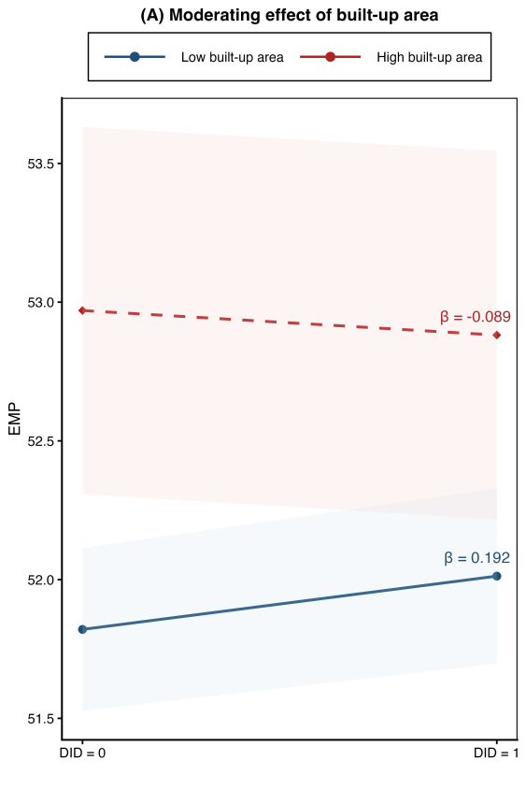 | 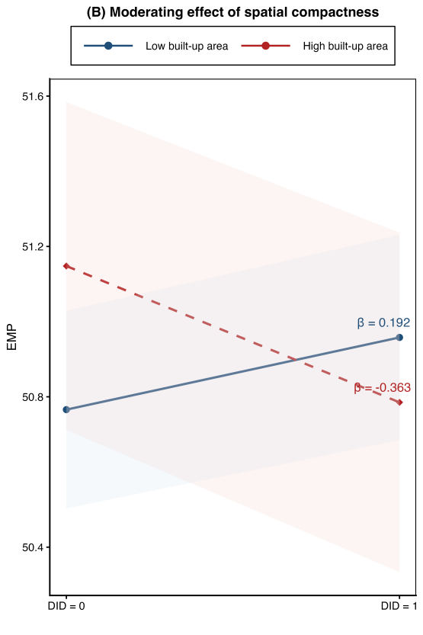
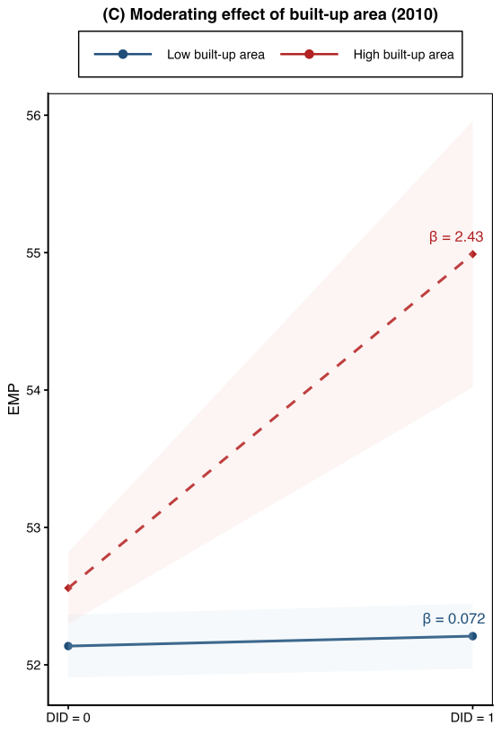 | 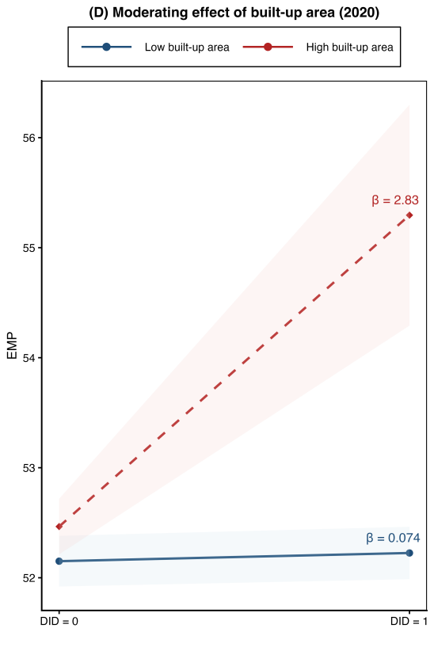
Fig.6. Moderating Effects of Urban Spatial Structure on Policy Impact Notes: Panels (A)–(D) plot marginal predictions of employment (EMP) from difference-in-differences models with interaction terms between DID and alternative measures. Predictions are evaluated at low and high values of the moderator. Shaded areas represent ±1 SE. β denotes the within-group DID effect. Differences in β across groups capture the moderating (interaction) effect.

4.5 Heterogeneity analysis
To assess heterogeneity, we estimate the baseline DID model separately by city type and compare the distributions of city-level treatment effects. Figure 5 reports the results, showing coefficient densities, group-specific mean effects (β_DID), and bootstrap-based p-values (500 replications) for cross-group differences.
4.5.1 Heterogeneity between Resource-Based and Non-Resource Cities
Panel A compares resource-based cities with non-resource cities. The estimated mean DID effect is positive and statistically significant in non-resource cities (β_{DID} = 0.067), while it is close to zero and insignificant in resource-dependent cities (β_{DID} = −0.012). The difference between the two groups is highly significant. This suggests that the NTUPP generates stronger employment gains in cities with more diversified economic structures, whereas resource dependence may constrain labor-market adjustment and limit policy effectiveness.
4.5.2 Heterogeneity between region
Panel B reveals substantial regional heterogeneity. The average treatment effect in eastern cities is large and strongly positive (β_{DID} = 0.321), whereas it is negative in non-eastern cities (β_{DID} = −0.084). The difference between the two groups is statistically significant. These findings indicate that cities in economically advanced regions benefit more from the NTUPP, likely due to stronger institutional capacity, higher marketization levels, and more dynamic private sectors.
4.5.3 Heterogeneity between Metropolitan and Non-Metropolitan Cities
Panel C indicates that the policy effect is more pronounced in metropolitan (core) cities. The estimated treatment effect is positive and statistically significant in core cities, whereas it is weaker and statistically insignificant in non-metropolitan cities. The difference between the two groups is statistically significant based on bootstrap tests. These findings suggest that metropolitan cities—characterized by stronger economic foundations, higher institutional capacity, and deeper labor markets—are better positioned to translate the NTUPP into improvements in employment quality.
4.5.4 Heterogeneity between Inflow and Non-Inflow Cities
Panel D examines heterogeneity by population inflow status. Cities experiencing sustained population inflows exhibit a strong and positive policy effect (β_{DID} = 0.363), while non-inflow cities display a slightly negative and insignificant effect (β_{DID} = −0.036). The difference between groups is highly significant. This indicates that labor mobility and demographic dynamism play a critical role in amplifying the employment-enhancing impact of the NTUPP.
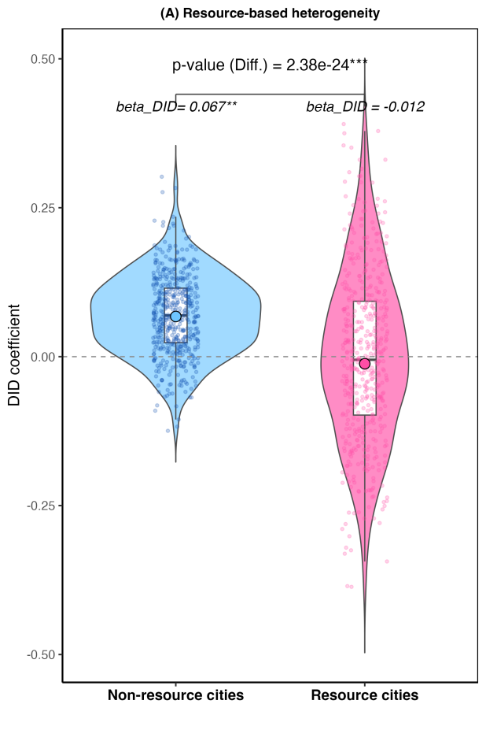 | 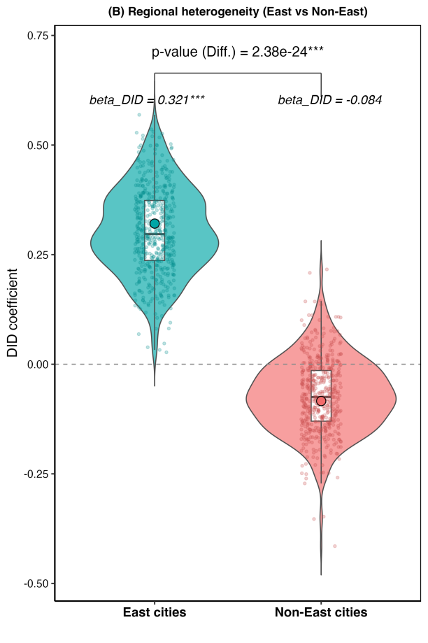
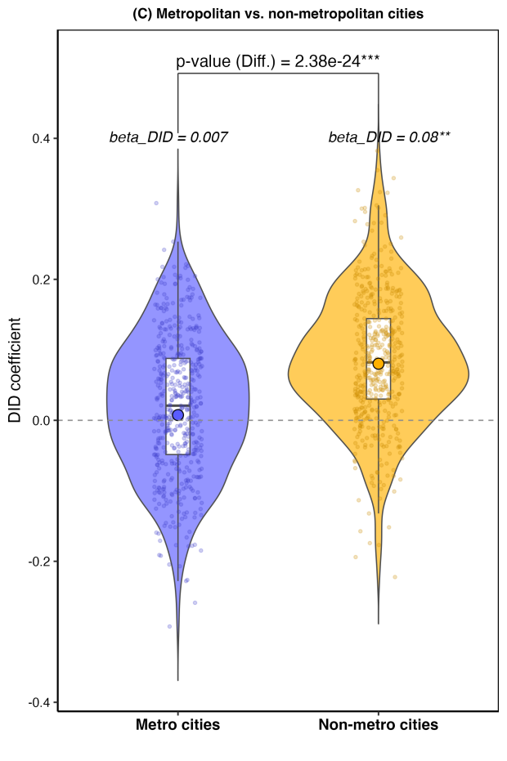 | 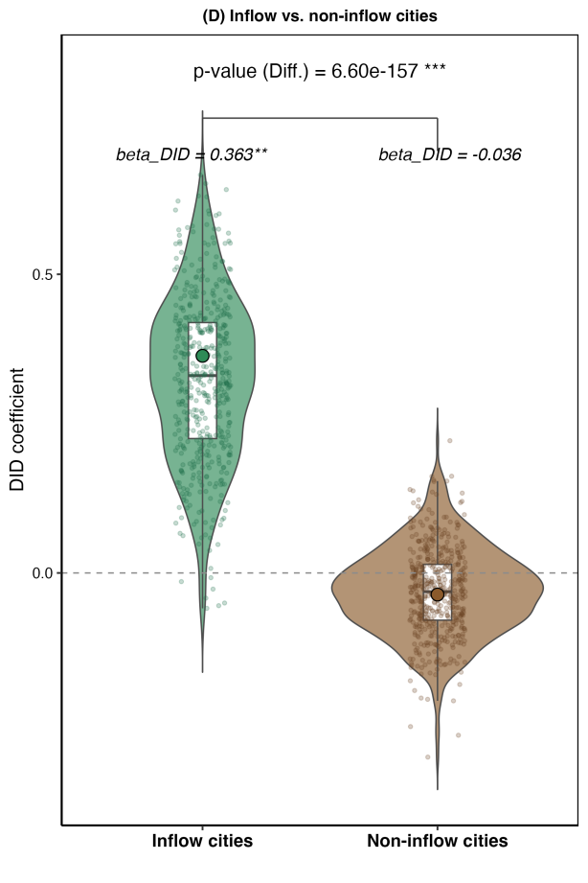
Fig.7.Heterogeneous Policy Effects across City Characteristics Notes: Panels (A)–(D) show the distribution of city-level DID coefficients across heterogeneous groups. Violin plots depict the density of estimates, with boxplots and dots summarizing their distribution. β_DID denotes group-specific mean effects. p-values (Diff.) are based on 500 bootstrap replications.

4.6 Further analysis: spatial spillover effects of the policy
The previous sections documented the direct effects of the New Urbanization Pilot Policy on urban employment quality. However, location-based policies may also generate externalities beyond targeted areas. Existing research suggests that institutional interventions can produce spillover effects on neighboring regions (Cao et al., 2022). To examine this possibility, we construct distance-based spillover measures following Cao et al. (2022). Specifically, we divide geographic distance into 50-kilometer bands and create dummy indicators capturing whether a prefecture-level city is located within a given distance range of any treated city in year t. These distance bands range from 0–50 km up to 350–400 km.
${EMP}_{it}=β_{0}$+$β_{1}{treat}_{it}∗{post}_{it}$+$\sum_{j=1}^{J}{φ_{it}{Distance}_{it}}\sum_{j=1}^{J}{φ_{it}{Controls}_{it}^{j}}+$
$μ_{t}+α_{i}+ε_{it}$ (7)
In this context, R represented geographic distance, segmented into intervals of 50 kilometers to form distance bands of [R−50,R], [R-50, R], [R−50,R]. The variable Distance_{it} was a dummy indicator that captured whether any other city within a specific distance range had been designated as a Green Finance Reform Pilot Zone in year t. Specifically, Distance_{it} =1 if there existed at least one prefecture-level city within the [50, 100], [100, 150], ..., or [300, 350] kilometer range that was selected as a pilot zone in year t; otherwise, the variable took the value 0.
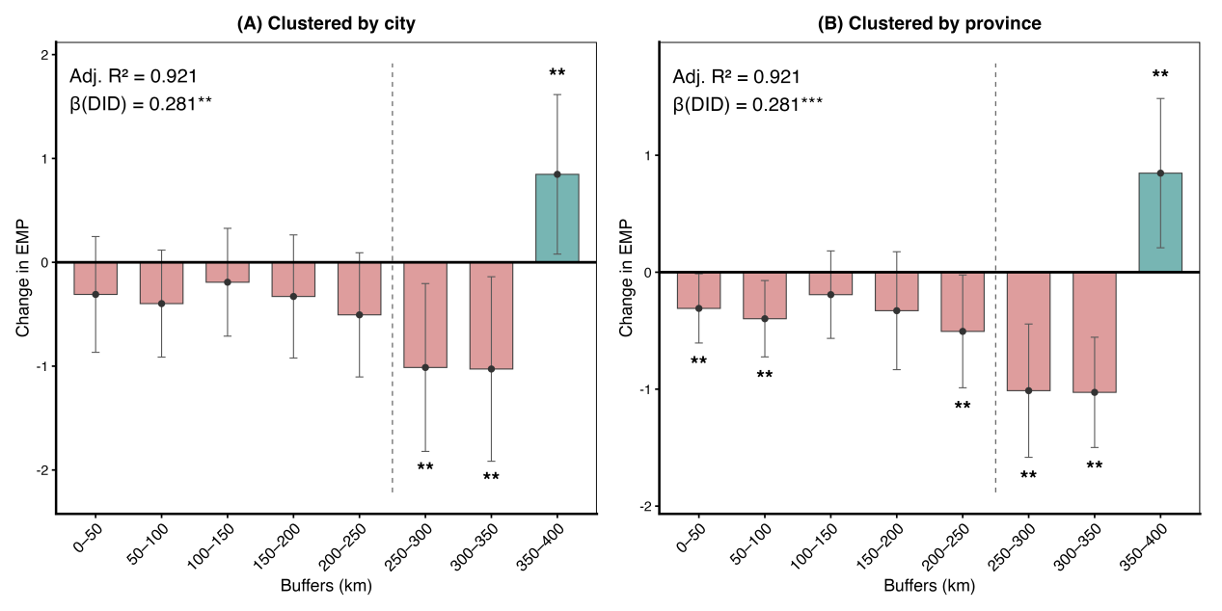
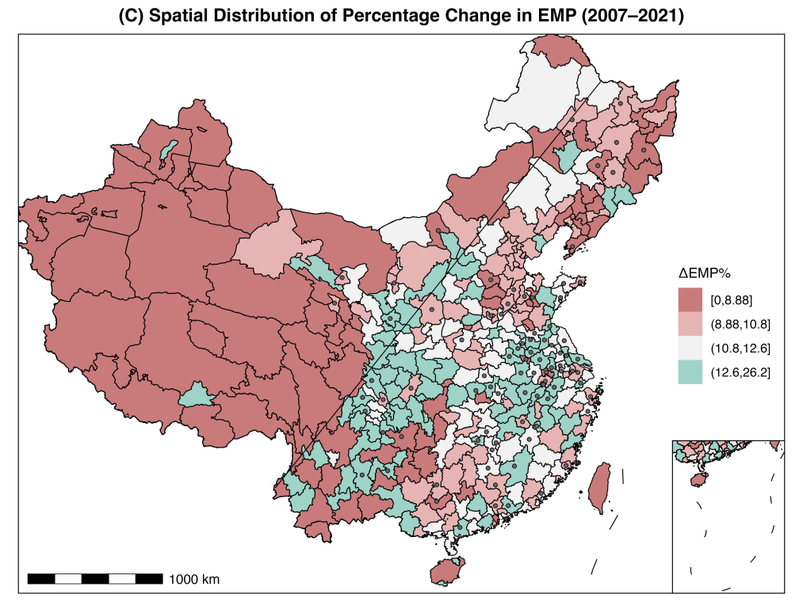
Fig. 8 Spatial Spillover Estimators
Figure 8 reports the estimated spillover coefficients across 50-kilometer distance bands. The effects are negative within 0–250 km, generally ranging from about −0.20 to −0.50, and become strongly negative and statistically significant in the 250–350 km range. In contrast, the coefficient turns positive and significant in the outermost 350–400 km band.These results indicate a clear distance-dependent spatial pattern: the policy generates short- to medium-range crowding or reallocation effects, while producing positive diffusion effects at greater distances.
5 Discussion and implication
This study investigates how the New-Type Urbanization Pilot Policy (NTUPP) affects employment quality and through which channels the effects operate. Our results show that the NTUPP significantly improves employment quality at the city level. We further identify two transmission channels—human capital accumulation and factor-market development—through which the policy exerts these positive effects. Spatial analysis reveals that vertical densification amplifies improvements in employment quality, while horizontal sprawl weakens them. In addition, the policy exhibits spatial spillovers concentrated within a medium range (100–200 km), whereas short-range siphoning effects may arise within 0–50 km.
Beyond these core findings, the study offers four key contributions. First, it provides credible city-level causal evidence that NTUPP enhances employment quality, addressing a gap in previous literature that has focused primarily on job quantity. Second, the paper incorporates 3D urban morphology into policy evaluation by pairing a multidimensional employment-quality index with CBHD30-based measures—Building Surface Fraction (BSF) and Mean Building Height (MBH). This framework allows us to distinguish vertical densification from horizontal sprawl and shows that compact, high-rise growth strengthens the policy’s impact. Third, we document substantial spatial heterogeneity: policy effects are stronger in eastern/southern/coastal and transport-hub cities but weaker in old-industrial, large, and provincial-capital cities. Fourth, we uncover meaningful spatial spillovers, which follow an inverted-U pattern, peaking at intermediate distances (100–200 km) but exhibiting short-range competition.
From a practical perspective, the findings provide policy guidance for urban governance in transitional economies. The NTUPP’s people-centered, top-down design effectively improves labor mobility, public service equalization, and job accessibility, ultimately benefiting migrant workers and residents of less-developed areas. Policymakers should recognize that the urban spatial form is not merely an outcome but an important lever: compactness and vertical densification shorten commutes, expand service coverage, and enhance labor-market matching, while extensive 2D expansion dilutes policy benefits. Moreover, because NTUPP impacts extend beyond administrative borders, cross-jurisdictional coordination—in transport planning, service provision, and labor placement—is indispensable for diffusing gains and mitigating short-range siphoning.
China’s new-type urbanization is transitioning from scale expansion to quality enhancement. Policy packages should therefore combine institutional reform with physical and social infrastructure provision. On the infrastructure side, priorities include improving multimodal public transit, last-mile connectivity, and reliable utilities (water, power, broadband). On the social services side, equal access to schooling for migrant children, portable health insurance, and broader social security coverage for flexible and platform workers are crucial. Cities should encourage compact, infill development and vertical renewal rather than low-density sprawl to ensure that more workers can reach jobs within a short travel time. Further, factor-market development—easing business entry, improving financing for young firms, linking transport hubs to regional value chains—and re-skilling support for old-industrial and resource-dependent cities are needed to translate urbanization gains into sustained employment improvements. Municipalities may also consider publishing a simple dashboard tracking employment-quality outcomes (e.g., wages, formality, stability, benefits, safety) and job accessibility, enabling more dynamic adjustments of subsidies, density targets, and training policies.
This study has limitations that point to promising directions for future work. First, our measurement of vertical urban growth relies on building-height data available only for 2010 and 2020; interpolation may miss short-term variation and introduce measurement noise. Second, although our city-level employment-quality index is multidimensional and transparent, it relies on administrative statistics and proxy variables (e.g., social-insurance coverage, average wages), which may underrepresent informality, contract quality, and job amenities, and may be sensitive to indicator selection and weighting. Consequently, our estimates of how NTUPP interacts with urban form and job quality should be interpreted conservatively. Future research integrating high-frequency 3D data, micro-level labor information, and distributional perspectives would allow more precise evaluation of timing, mechanisms, and heterogeneous impacts.
6. Conclusions
This study shows that China’s New-type Urbanization Pilot Policy (NTUPP) does more than accelerate city growth—it improves the quality of urban employment. Using a panel of 287 prefecture-level cities (2007–2021) and a suite of identification strategies (multi-period DID with city and year fixed effects, PSM, IV-2SLS, and DML), we find a robust average increase of about 12.13% in a multidimensional employment-quality index for pilot cities. Mechanism analyses indicate that the policy works chiefly through human capital accumulation—via education, training, and health coverage that raise worker productivity—and through market development, which lowers transaction costs and improves the allocation of labor and capital.
The effects are conditioned by urban form. Compact layouts and vertical densification enhance job accessibility and service coverage, thereby amplifying policy gains, while horizontal sprawl lengthens commutes, fragments services, and erodes benefits. We also document heterogeneity: impacts tend to be stronger in eastern and southern regions, coastal cities, and transport hubs, and weaker in old-industrial, resource-dependent, very large, and some provincial-capital cities where saturation and structural rigidities limit marginal improvements. Finally, we find spatial spillovers: nearby non-pilot cities gain at middle distances, though very close neighbors may experience short-run siphoning.
Overall, the evidence supports a people-centered approach to urbanization in which investments in skills, equal public services, and market-enabling institutions are coupled with morphology-aware planning that favors infill and vertical renewal over peripheral sprawl. When these elements align, urbanization can be steered toward better jobs—not merely more jobs—and the employment gains can be shared more broadly across regions.

References
Abbasi, K. R., Shahbaz, M., Jiao, Z., & Tufail, M. (2021). How energy consumption, industrial growth, urbanization, and CO₂ emissions affect economic growth in Pakistan? A novel dynamic ARDL simulations approach. Energy, 221, 119793.
Aghion, P., Antonin, C., & Bunel, S. (2021). The power of creative destruction: Economic upheaval and the wealth of nations. Harvard University Press.
An, R., Tong, Z., Tan, B., Xiong, Q., Luo, Y., Liu, Y., ... & Yang, X. (2025). Revealing the relationship between 2D/3D built environment and jobs-housing separation coupling nonlinearity and spatial nonstationarity. Journal of Transport Geography, 123, 104112.
asghar Pilehvar, A. (2021). Spatial-geographical analysis of urbanization in Iran. Humanities and Social Sciences Communications, 8(1), 1–12.
Banerjee, A., Duflo, E., & Qian, N. (2020). On the road: Access to transportation infrastructure and economic growth in China. Journal of Development Economics, 145, 102442.
Bastiaanssen, J., Johnson, D., & Lucas, K. (2022). Does better job accessibility help people gain employment? The role of public transport in Great Britain. Urban Studies, 59(2), 301–322.
Bleakley, H., & Lin, J. (2012). Portage and path dependence. The Quarterly Journal of Economics, 127(2), 587–644.
CAO, Y., Chen, S., et al. (2022). Rebel on the canal: Disrupted trade access and social conflict in China, 1650–1911. American Economic Review, 112(5), 1555–1590.
Chen, M., Huang, X., Cheng, J., Tang, Z., & Huang, G. (2023). Urbanization and vulnerable employment: Empirical evidence from 163 countries in 1991–2019. Cities, 135, 104208.
Cheng, F., & Wang, Y. (2021). Research and application of 3D visualization and Internet of Things technology in urban land use efficiency management. Displays, 69, 102050.
Chernozhukov, V., Chetverikov, D., Demirer, M., Duflo, E., Hansen, C., Newey, W., & Robins, J. (2018). Double/debiased machine learning for treatment and structural parameters. Econometrics Journal, 21(1), C1–C68.*
Chen, Z., Chen, T., Lin, Y., & Wang, J. (2025). Building tall, falling short: An empirical assessment of Chinese skyscrapers. Journal of Urban Economics, 145, Article 103731.
Couture, V., Gaubert, C., Handbury, J., & Hurst, E. (2024). Income growth and the distributional effects of urban spatial sorting. Review of Economic Studies, 91(2), 858–898.
Deng, B., & Zhong, F. (2023). Leading or constraining? Development of new-type urbanization under economic growth targets. Land, 12(4), 916.
Delmelle, E., Nilsson, I., & Adu, P. (2021). Poverty suburbanization, job accessibility, and employment outcomes. Social Inclusion, 9(2), 166–178.
Duernecker, G., & Herrendorf, B. (2022). Structural transformation of occupation employment. Economica, 89(356), 789–814.
Duranton, G., & Puga, D. (2020). The economics of urban density. Journal of Economic Perspectives, 34(3), 3–26.
Duranton, G., & Puga, D. (2023). Urban growth and its aggregate implications. Econometrica, 91(6), 2219–2259.
Genovese, D., Candiloro, S., D’Anna, A., Dettori, M., Restivo, V., Amodio, E., & Casuccio, A. (2023). Urban sprawl and health: A review of the scientific literature. Environmental Research Letters, 18(8), 083004.
Glaeser, E. L., Kallal, H. D., Scheinkman, J. A., & Shleifer, A. (1992). Growth in cities. Journal of Political Economy, 100(6), 1126–1152.
Glaeser, E. L., & Maré, D. C. (2001). Cities and skills. Journal of Labor Economics, 19(2), 316–342.
Gong, J., & Xu, L. (2024). The driving effect of industrial upgrading on new-type urbanization in Zhejiang Province. Journal of Theory and Practice of Management Science, 4(3), 44–54.
Guo, J., Yu, Z., Ma, Z., Xu, D., & Cao, S. (2022). What factors have driven urbanization in China? Environment, Development and Sustainability, 24(5), 6508–6526.
He, S., Yu, S., Li, G., & Zhang, J. (2020). Exploring the influence of urban form on land-use efficiency from a spatiotemporal heterogeneity perspective: Evidence from 336 Chinese cities. Land Use Policy, 95, 104576.
Hosseinioun, M., Neffke, F., Zhang, L., & Youn, H. (2025). Skill dependencies uncover nested human capital. Nature Human Behaviour, 1–15.
International Labour Organization (ILO). (2012). Decent work indicators: Concepts and definitions.
Joshanloo, M. (2023). A new index of perceived job quality in 116 countries: Associations with working hours and other national characteristics. Social Sciences, 12(9), 492.
Lian, H., Kong, S., & Yu, Y. (2025). Tight spaces, strong cities: The resilience payoff of urban compactness. Land Use Policy, 156, 107621.
Li, H., & Song, W. (2020). Evolution of rural settlements in the Tongzhou District of Beijing under the new-type urbanization policies. Habitat International, 101, 102198.
Li, Z., Shi, Y., Wojewodzki, M., Wei, Y., & Guo, M. (2024). The impact of new-type urbanization policy on urban green total factor productivity: New evidence from China. Sustainability, 16(12), 5220.
Liao, B., Li, L., & Tian, C. H. (2024). How do the pilot policies of new urbanization improve uneven development? Economic Analysis and Policy, 82, 86–103.
Liu, T., et al. (2023). The impact of differentiated development of the digital economy on employment quality—An empirical analysis based on provincial data from China. Sustainability, 15(19), 14176.
Lyons, T., & Ewing, R. (2021). Does transit moderate spatial mismatch? The effects of transit and compactness on regional economic outcomes. Cities, 113, 103160.
Mun, J., Lee, J. S., & Kim, S. (2024). Effects of urban sprawl on regional disparity and quality of life: A case of South Korea. Cities, 151, 105125.
Nica, E., Poliak, M., Alpopi, C., Kliestik, T., Manole, C., & Burlacu, S. (2023). Impact of trade, FDI, and urbanization on female employment system in SAARC: GMM and quantile regression approach. Systems, 11(3), 137.
Park, J. I. (2023). Re-urbanization pattern of manufacturing and characteristics of urban manufacturing in South Korea. Cities, 137, 104330.
Peckham, T., Flaherty, B., Hajat, A., Fujishiro, K., Jacoby, D., & Seixas, N. (2022). What does non-standard employment look like in the United States? An empirical typology of employment quality. Social Indicators Research, 163(2), 555–583.
Qi, Y., Liu, C., & Ding, S. (2020). Digital economy development, employment structure optimization, and employment quality improvement. Economic Perspectives (Jingji Xue Dongtai), (11), 17–35. (In Chinese)
Shu, T., Yu, T., Liao, X., & Yang, S. (2024). Unearthing the impact of urban sprawl on transport carbon dioxide emissions: Fresh evidence from 274 Chinese cities. Journal of Geographical Sciences, 34(10), 1953–1976.
Soltani, A., Azizi, P., Rahimioun, A., & Sedaghatfard, M. (2025). Volumetric urban sprawl: Horizontal and vertical growth in two metropolitans. Journal of Urban Management, 14(1), Article 105821.*
Sun, M., & Xu, P. (2025). Accumulation and spatial spillover of knowledge capital, and formation of urban agglomeration innovation centers: A case study of the Yangtze River Delta urban agglomeration. Frontiers of Economics in China, 20(1), 54–85.
Van Hiep, N. (2021). High-quality human resources development. Journal of University of Shanghai for Science and Technology, 23(1), 3818–3830.
Wang, H., & Qiu, Y. (2023). Effect of new urbanization on cities’ innovation in China: Evidence from a quasi-natural experiment of a comprehensive pilot. PLOS ONE, 18(4), e0284772.
Wang, J., Luo, X., Liang, X., & Ning, C. (2025). New-type urbanization and regional public health: Mechanisms and effects. Frontiers in Public Health, 13, 1513173.
Wang, Q., Li, S., & Chen, Z. (2025). The Economic Impacts of Vertical Development: Evidence from Chinese Skyscrapers. The Journal of Real Estate Finance and Economics.
Wang, T., Li, S., & Gao, D. (2024). What factors have an impact on the employment quality of platform-based flexible workers? Evidence from China. Heliyon, 10(2), e24318.
Wang, X., & Zhang, X. (2023). A regional comparative study on the mismatch between population urbanization and land urbanization in China. PLOS ONE, 18(6), e0287366.
Wu, X., Huang, Y., & Gao, J. (2022). Impact of industrial agglomeration on new-type urbanization: Evidence from the Pearl River Delta urban agglomeration of China. International Review of Economics & Finance, 77, 312–325.
Xu, H., & Jiao, M. (2021). City size, industrial structure and urbanization quality—A case study of the Yangtze River Delta urban agglomeration in China. Land Use Policy, 111, 105735.
Yang, C., & Zhao, S. (2022). Urban vertical profiles of three most urbanized Chinese cities and the spatial coupling with horizontal urban expansion. Land Use Policy, 113, 105919.
Yang, L., Ding, H., Lin, C., Chen, X., Chen, Y., Huang, M., Zhao, X., Yang, X., & Zhao, W. (2024). CBHD30: Chinese Building Height Data at 30m Resolution (Version 1) DatasetData setDataset. Zenodo. https://zenodo.org/records/14253539
Yuan, C., Zhang, B., Xu, J., Lyu, D., Liu, J., Hu, Z., & Han, Y. (2025). Impact of new-type urbanization pilot policy on public service provision: Evidence from China. Cities, 161, 105853.
Yu, H., et al. (2024). Dynamics of urban sprawl: Deciphering the role of land prices and transportation costs in government-led urbanization. Journal of Urban Management, 13(4), 736–754.
Zhang, M., Tang, J., & Gao, J. (2023). Examining the effects of built environments and individual characteristics on commuting time under spatial heterogeneity: An empirical study in China using HLM. Land, 12(8), 1596.
Zhao, F., Tang, L., Qiu, Q., & Wu, G. (2020). The compactness of spatial structure in Chinese cities: Measurement, clustering patterns and influencing factors. Ecosystem Health and Sustainability, 6(1), 1743763.
Zhao, W., Ding, H., Na, J., Li, M., & Tiede, D. (2023). Height estimation from single aerial imagery using contrastive learning based multi-scale refinement network. International Journal of Digital Earth,16(1), 2322-2340.
Zheng, X., Wang, R., & Du, Q. (2020). How does industrial restructuring influence carbon emissions: City-level evidence from China. Journal of Environmental Management, 276, 111093.
Zhou, Y., Wang, Y., & Wang, Q. (2024). Utilization of foreign investment in the productive service industry in Hubei Province, China, and its optimization countermeasures. PLOS ONE, 19(6), e0302494.

High-quality employment index is measured based on the entropy method. The computational procedure is omitted from the main text for brevity.
One-to-many propensity score matching is conducted with a caliper of 0.01. For brevity, the results of balance diagnostics, kernel density plots before and after matching, and additional robustness checks are omitted from this section.
Prior to the event study estimation, we applied one-to-many propensity score matching (PSM) with a caliper of 0.01 to preprocess the sample. To avoid multicollinearity, the pre-treatment period Pre5 was dropped and served as the reference period.
The index of city compactness is calculated by following equation: ${spatcompact}_{i}=\frac{\sum_{j≠k}{d_{jk}}}{R_{i}∙N_{i}(N_{i}−1)}$. Here, N_{i} denoted the number of grid cells within the largest contiguous built-up area of city i, and d_{jk} represented the Euclidean distance between any two points j and k within this area. The term R_{i} referred to the radius of a circle with the same area as the built-up region. A smaller value of this index indicated a more compact spatial distribution within the city, reflecting a more concentrated urban form.

